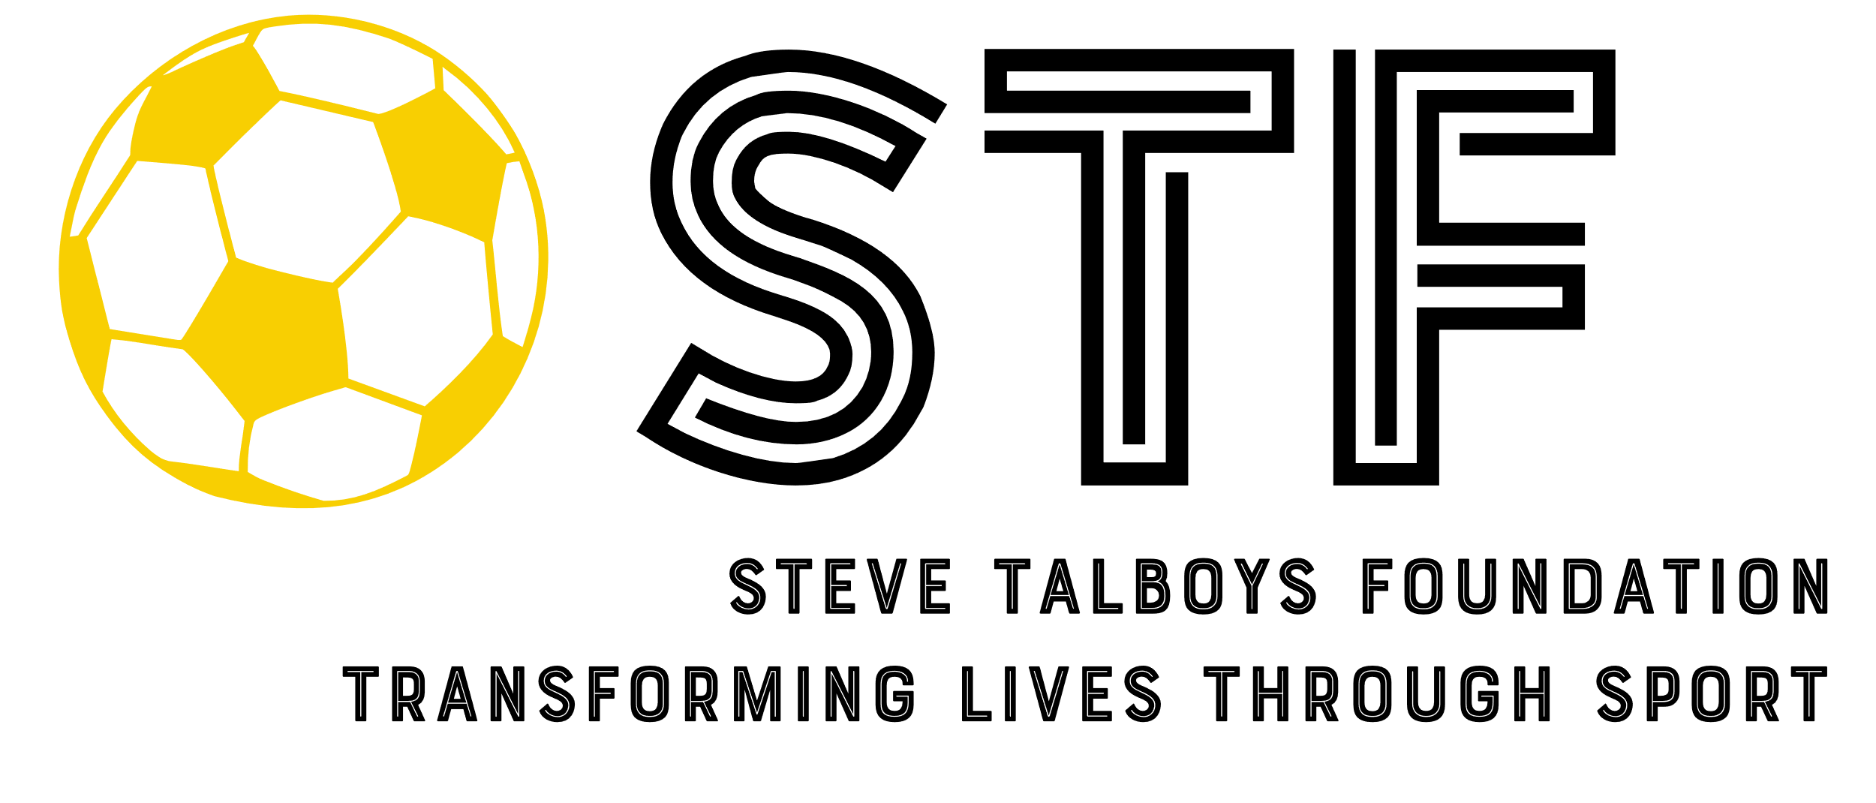
APPLICATION FROM INDIVIDUAL
The Steve Talboys Foundation supports children and young people in Surrey, Greater London, Bristol and Gloucestershire to experience the life changing benefits of amateur sport in their local community.

This application form is for individual children or young people who required funding to take part in a sporting activity in conjunction with an amateur sports club, association or trust.

- APPLICANT DETAILS

Name of child/young person and date of birth

Address of child/young person (including postcode)

Name of person submitting application and relationship to applicant

Telephone and email address of person applying on child’s behalf.

Is the club the child or young person is associate with a fully constituted amateur sports club, association, or trust in Surrey, Greater London, Bristol and Gloucestershire ? (yes/no)

Name of club

Please provide name and contact details of a person at the club so we can contact them to verify the application

Where appropriate, please provide details of previous applications to The Steve Talboys Foundation
- AMOUNT REQUESTED

Amount requested £

Name of project, activity, or piece of equipment
Please include documentary evidence to support the planned expenditure e.g. quotes, invoices etc

Please tell us how our funding will benefit the child or young person?

- REFEREES
Please provide details of two referees who are prepared to support your application. Please note – referees must not be related to you.

Referee 1:
Name
Job title
Email
Phone

Referee 2:
Name
Job title
Email
Phone

- Where did you hear about the Steve Talboys Foundation?

- Please verify that all information is correct
To the best of my knowledge all the information provided on this application is correct. I give permission to the Steve Talboys Foundation:
- To record and store the information given in this form electronically, and to contact me by telephone, post or email in connection with this application; and
- If my application is successful, to give details of the grant and to share any photographs provided by the club on its website, social media, annual report pertaining to the grant.
- To keep me informed of news and events at The Steve Talboys Foundation, although I understand that I may unsubscribe at any time

I confirm that I have read and understood The Steve Talboys Foundation Grant-Making policy. I agree to advise The Steve Talboys Foundation immediately if, at any time before an award is made, there are significant changes in the information given by me on this form.

I give my consent to The Steve Talboys Foundation to providing a copy of this application form by e-mail to the referees named in it.

Applicant’s name and signature

Date

